Problem : Collision using chaining

#include <stdio.h>

#include <stdlib.h>

#define SIZE 100

typedef struct node {

long int phno;

struct node *next;

} Node;

typedef struct hash {

struct node *head;

int count;

} HashTable;

HashTable *init()

{

HashTable *temp = calloc(SIZE, sizeof(HashTable));

for (int i = 0; i < SIZE; ++i)

{

temp[i].head = NULL;

temp[i].count = 0;

}

return temp;

}

void destroy_hash(HashTable *hashtable)

{

Node *temp = NULL, *to_del = NULL;

for (int i = 0; i < SIZE; ++i)

{

temp = hashtable[i].head;

hashtable[i].head = NULL;

for (int j = 0; j < hashtable[i].count; ++j)

{

to_del = temp;

temp = temp->next;

free(to_del);

}

}

free(hashtable);

}

void insert(HashTable *hashtable,long int phno)

{

int hash = phno % SIZE;

Node *new_node = (Node *)malloc(sizeof(Node));

new_node->phno = phno;

new_node->next = hashtable[hash].head;

hashtable[hash].head = new_node;

++hashtable[hash].count;

}

void delete(HashTable *hashtable,long int phno)

{

int hash = phno % SIZE;

Node *temp = hashtable[hash].head, *prev = NULL;

while (temp != NULL)

{

if (temp->phno == phno)

{

if (prev != NULL)

{

prev->next = temp->next;

--hashtable[hash].count;

free(temp);

return;

}

else

{

hashtable[hash].head = temp->next;

--hashtable[hash].count;

free(temp);

return;

}

}

prev = temp;

temp = temp->next;

}

printf("phno not found in hash table\n");

}

void search(HashTable *hashtable,long int phno)

{

int hash = phno % SIZE;

Node *temp = hashtable[hash].head;

while (temp != NULL)

{

if (temp->phno == phno)

{

printf("%s\n","Phone number found");

return;

}

temp=temp->next;

}

printf("phno not found in hash table\n");

}

int main()

{

HashTable *p=init();

int ch;

long int num;

while(1)

{

printf("Enter 1 for inserting numbers\n2 for deleting a particular number\n3 for searching a phone number in the hash table\n4 for deleting the hash table\n5 for exit\n");

scanf("%d",&ch);

switch(ch)

{

case 1:

printf("%s\n","Enter phone number to be inserted");

scanf("%ld",&num);

insert(p,num);

break;

case 2:

printf("%s\n","Enter phone number to be deleted");

scanf("%ld",&num);

delete(p,num);

break;

case 3:

printf("%s\n","Enter phone number to be searched");

scanf("%ld",&num);

search(p,num);

break;

case 4:

destroy_hash(p);

default:

exit(0);

}

}

}

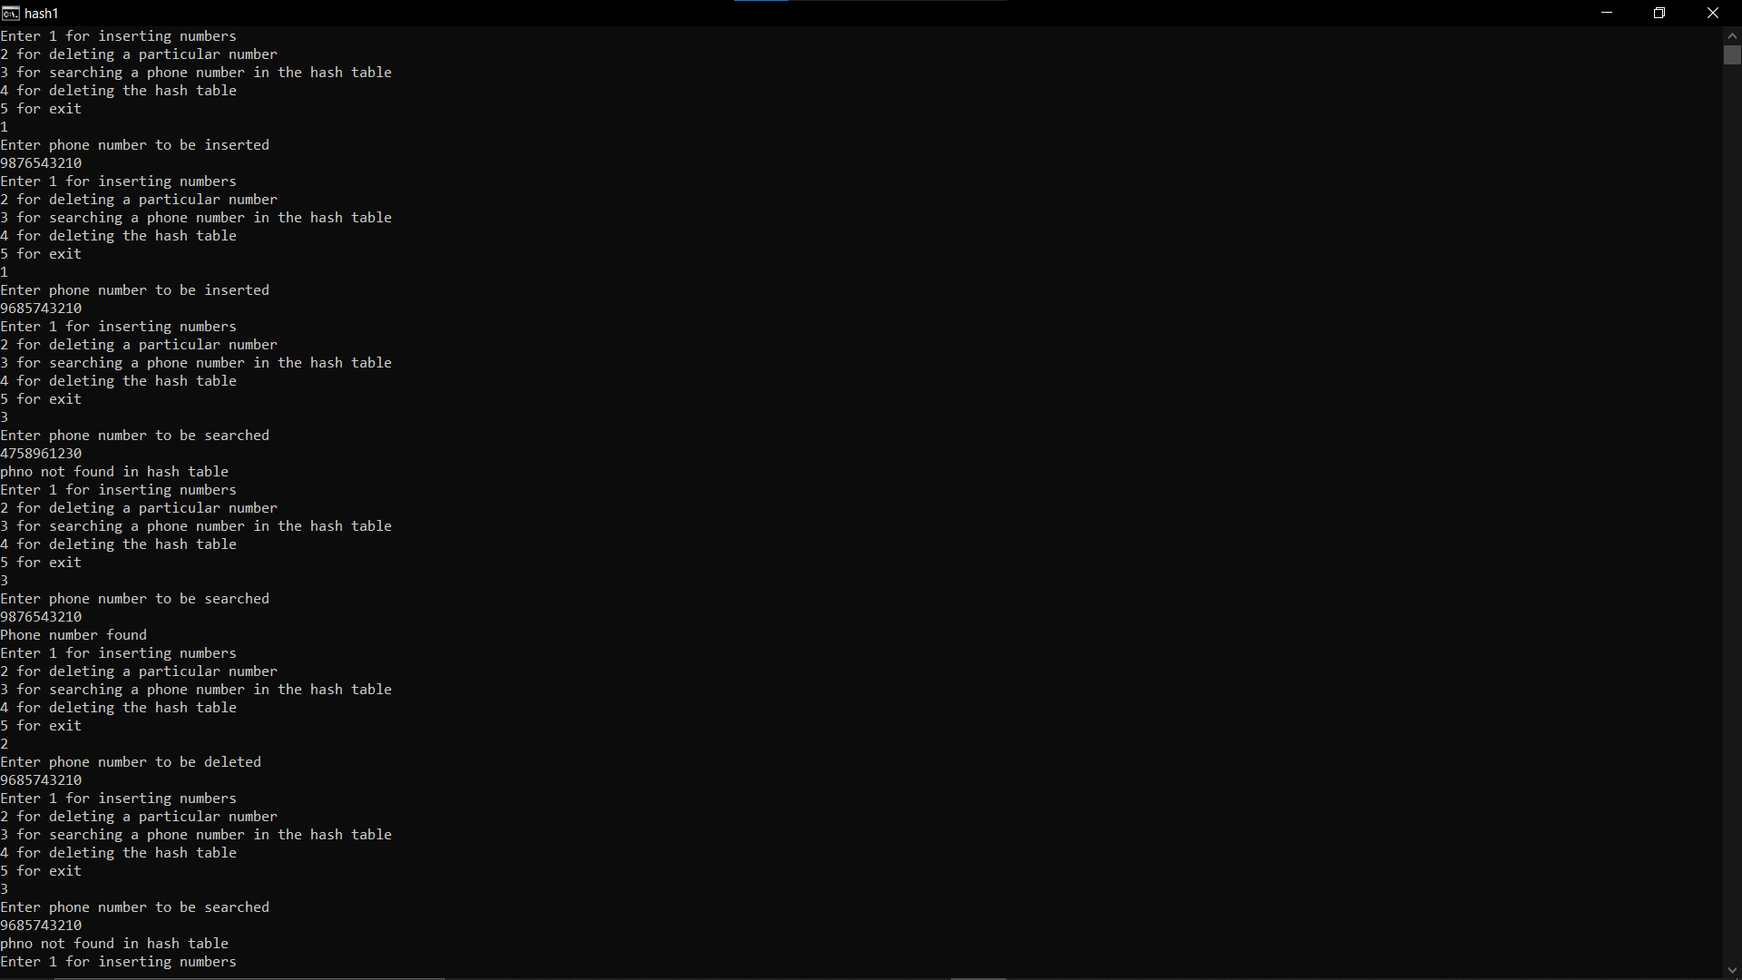

Problem: Hashing using linear probing

#include <stdio.h>

#include <stdlib.h>

#define SIZE 100

typedef struct {

long int *table;

int size;

} HashTable;

HashTable *init()

{

HashTable *temp = malloc(sizeof(HashTable));

temp->table = calloc(SIZE, sizeof(int));

for (int i = 0; i < SIZE; ++i) {

temp->table[i] = -1;

}

temp->size = SIZE;

return temp;

}

void destroy_table(HashTable *htable)

{

htable->size = 0;

free(htable->table);

}

void insert(HashTable *htable,long int phno)

{

int hash = phno % htable->size;

int count = 0;

while (count < htable->size)

{

if (htable->table[hash] == -1)

{

htable->table[hash] = phno;

break;

}

++hash;

++count;

if (hash == htable->size)

{

hash = 0;

}

}

}

int search(HashTable *htable, long int phno)

{

int hash = phno % htable->size;

int count = 0;

while (count < htable->size)

{

if (htable->table[hash] == phno)

{

return 1;

}

++hash;

++count;

}

return 0;

}

void delete (HashTable *htable, long int phno)

{

int hash = phno % htable->size;

int count = 0;

while (count < htable->size)

{

if (htable->table[hash] == phno)

{

htable->table[hash] = -1;

printf("%s\n","Number deleted" );

return;

}

++hash;

++count;

}

printf("%s\n","Number not found" );

}

int main()

{

HashTable *p=init();

int ch;

long int num;

while(1)

{

printf("Enter 1 for inserting numbers\n2 for deleting a particular number\n3 for searching a phone number in the hash table\n4 for deleting the hash table\n5 for exit\n");

scanf("%d",&ch);

switch(ch)

{

case 1:

printf("%s\n","Enter phone number to be inserted");

scanf("%ld",&num);

insert(p,num);

break;

case 2:

printf("%s\n","Enter phone number to be deleted");

scanf("%ld",&num);

delete(p,num);

break;

case 3:

printf("%s\n","Enter phone number to be searched");

scanf("%ld",&num);

int j=search(p,num);

if(j==1)

printf("%s\n","Number found");

else

printf("%s\n","Number not found");

break;

case 4:

destroy_table(p);

default:

exit(0);

}

}

}

